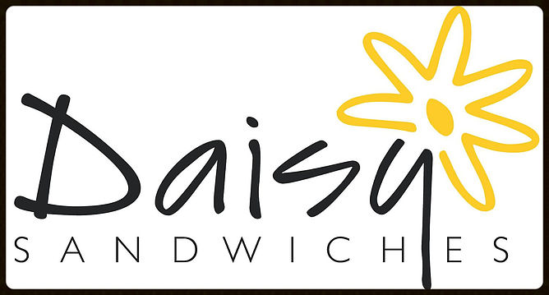

We are famous for our tasty hand baked savouries & delicious cakes

Every day we have a selection of savoury pastries on offer. Our regulars include, vegetarian samosas (vegan friendly), homemade bacon, cheddar & tomato turnovers & our delicious sausage rolls which can be flavoured with either English Mustard or Caramalised Red Onion Marmalade.

We also have guest savoury pastries, for example Spinach & Cheddar Chickpea Rolls & Croissant Melts.

We bake all our cakes & muffins. We use free range eggs & English butter.

Our daily cakes include:

- Chocolate Brownies
- All Butter Shortbread
- Caramel Crunch
- Rocky Road
- Gluten & Dairy Free Chocolate Chip & Peanut Butter Cookies
- Low Fat Banana & Raisin Bran Muffins
- All butter flapjack
- Banana & Raisin flapjack (vegan friendly)

See specials on our homepage to see what’s baking today!

