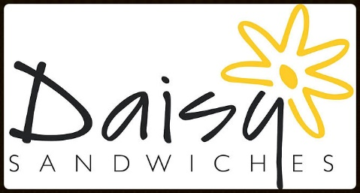

Breakfast Menu
We offer a range of delicious breakfast options to kick start your day. As always, our products are made to order, and therefore, completely customisable.

Hot Bacon Sandwich £3.60
Hot Sausage Sandwich £3.60
Hot Sausage, Bacon & Egg Sandwich £4.50
Toast with jam, marmite or marmalade £2.00
Croissants/pain au chocolat £1.50
Low fat banana bran muffin £2.00
Avocado on toast £2.75

